Tuolumne County Fire Department

“At-A-Glance”

November
2023
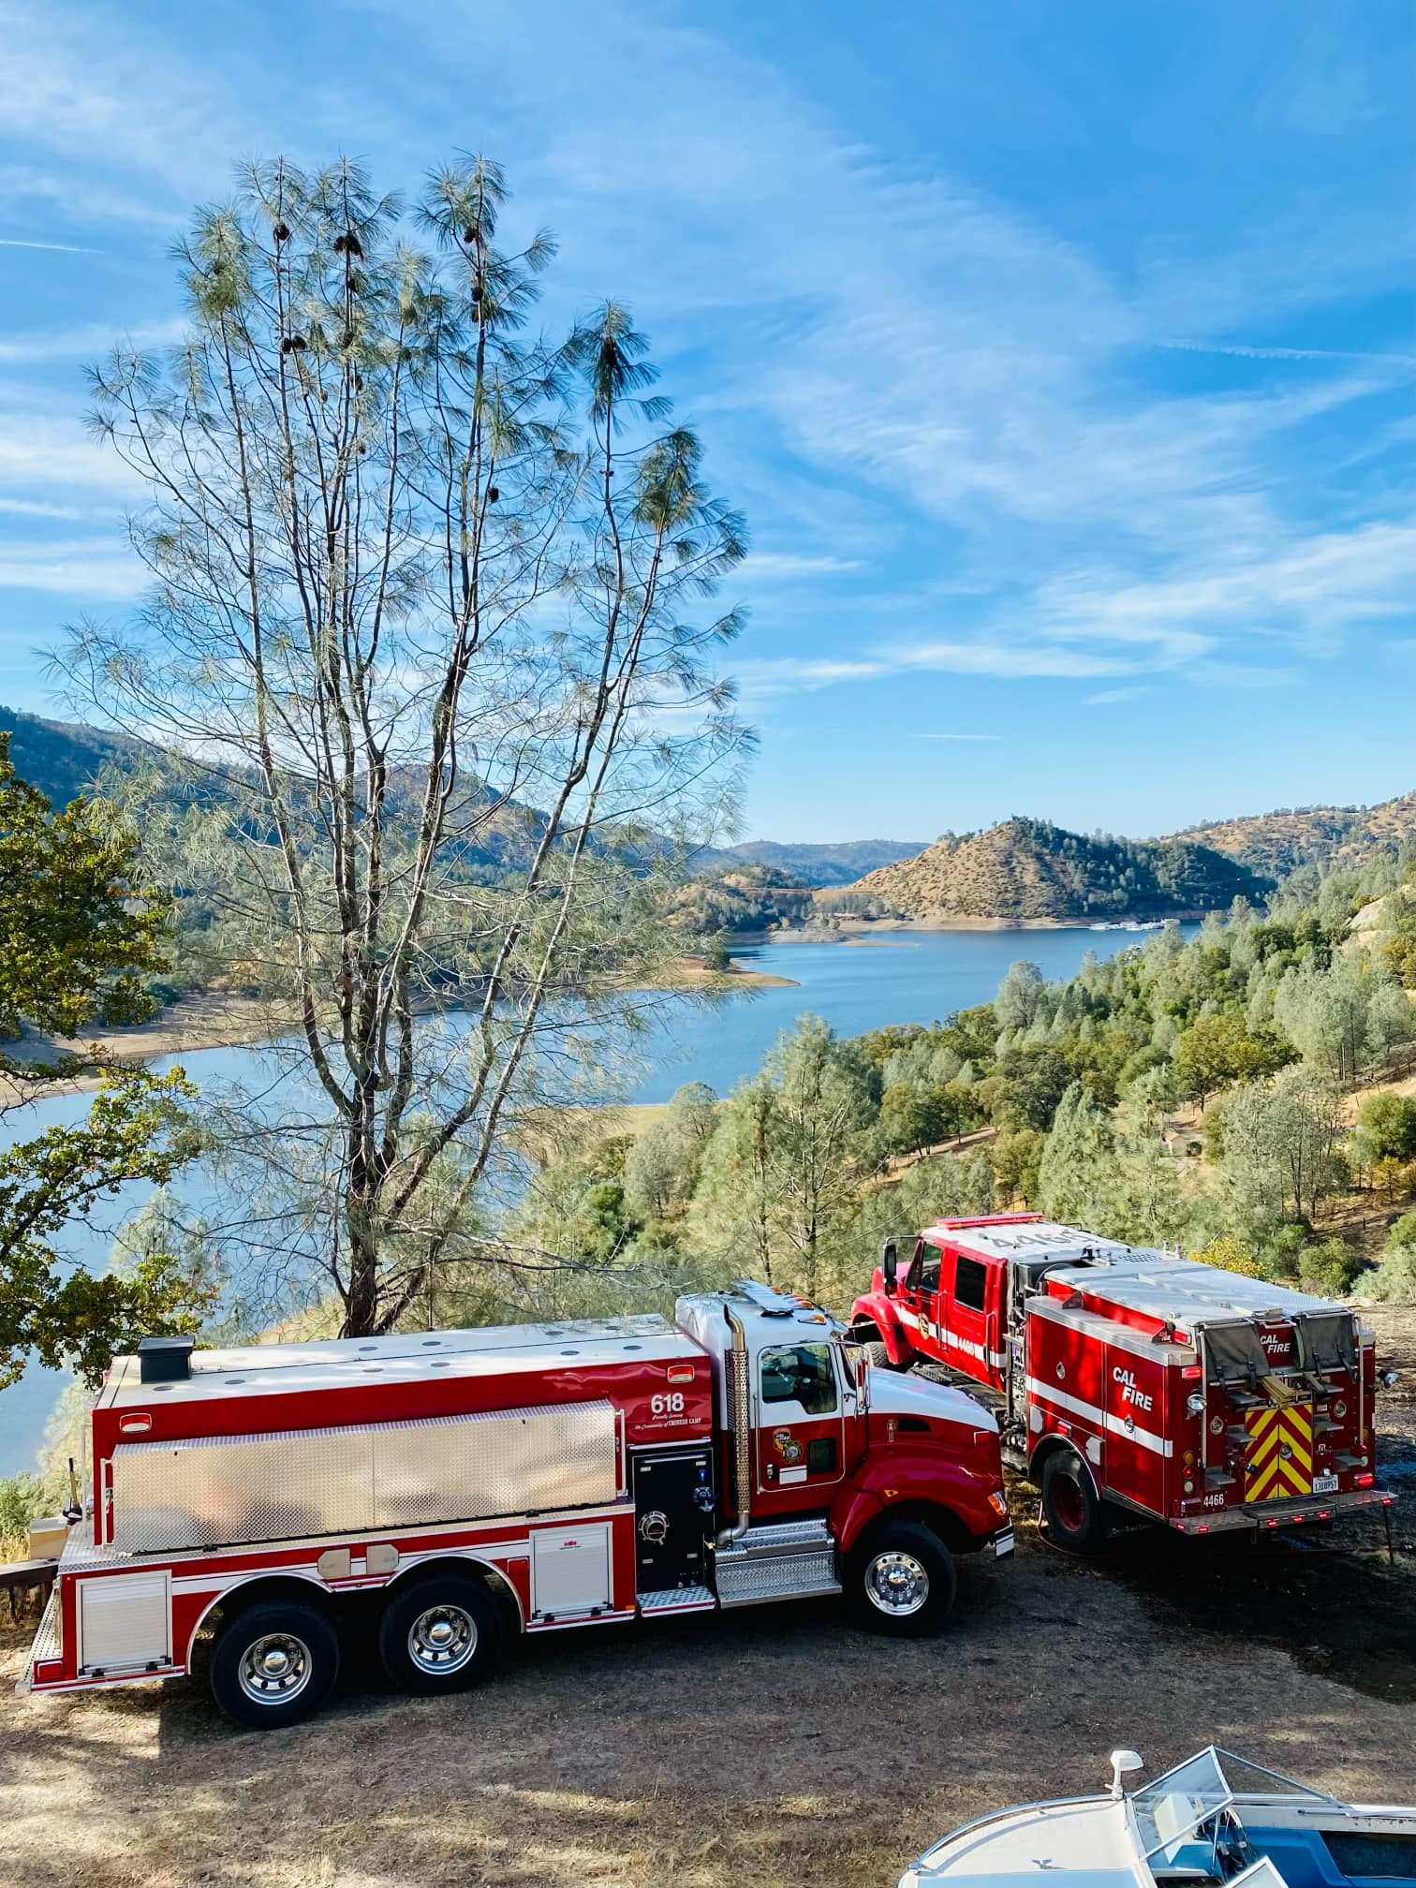

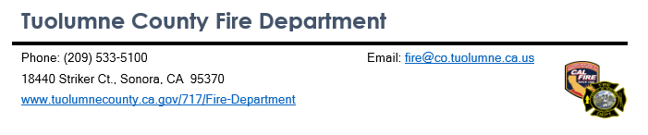

Tuolumne County Fire Department Call Totals
November 2023
Incident Totals:
Total Incidents: 770
Medical Aids: 524
Structure Fires: 17
Vegetation Fires: 27
Other Type Fires: 81
Hazardous Conditions: 19
Other Incident Types: 102
Tuolumne County Station Call Totals:
Mono Village Station 51: 233
Ponderosa Hills Station 53: 24
Long Barn Station 54: 8 Calls absorbed by other Stations
Pinecrest Station 55: 5
Mono Vista Station 56: 101
Phoenix Lake Station 57: Calls absorbed by other Stations
Cedar Ridge Station 58: 18
Chinese Camp Station 61: 38
Don Pedro Station 64: 11
Jamestown Station 76: 174
Groveland Station 63/78: 52
Columbia Station 74: 42 calls ran by Station 79 personnel
Columbia College Station 79: 64
Prevention Division:
Plans Reviews: 39
Inspections: 47
**Incident totals include incidents that the fire station was dispatched to, and may have been automatic aid to other agencies through the Tuolumne County Automatic Aid Agreement**
Significant Incidents
11/1/2023
At approximately 9:19 AM resources from the Tuolumne County Fire Department, CAL FIRE Tuolumne-Calaveras Unit, Twain Harte Fire Department, Tuolumne Rancheria Fire Department, Mi-Wuk Sugar Pine Fire Protection District, and Tuolumne Fire Protection District responded to a reported residential structure fire in the community of Ponderosa Hills. When resources arrived on scene the discovered a single-family home approximately 25% involved and threatening another structure. Firefighters went to work performing an aggressive attack and contained the fire in about 50 minutes. The cause of the fire remains under investigation.
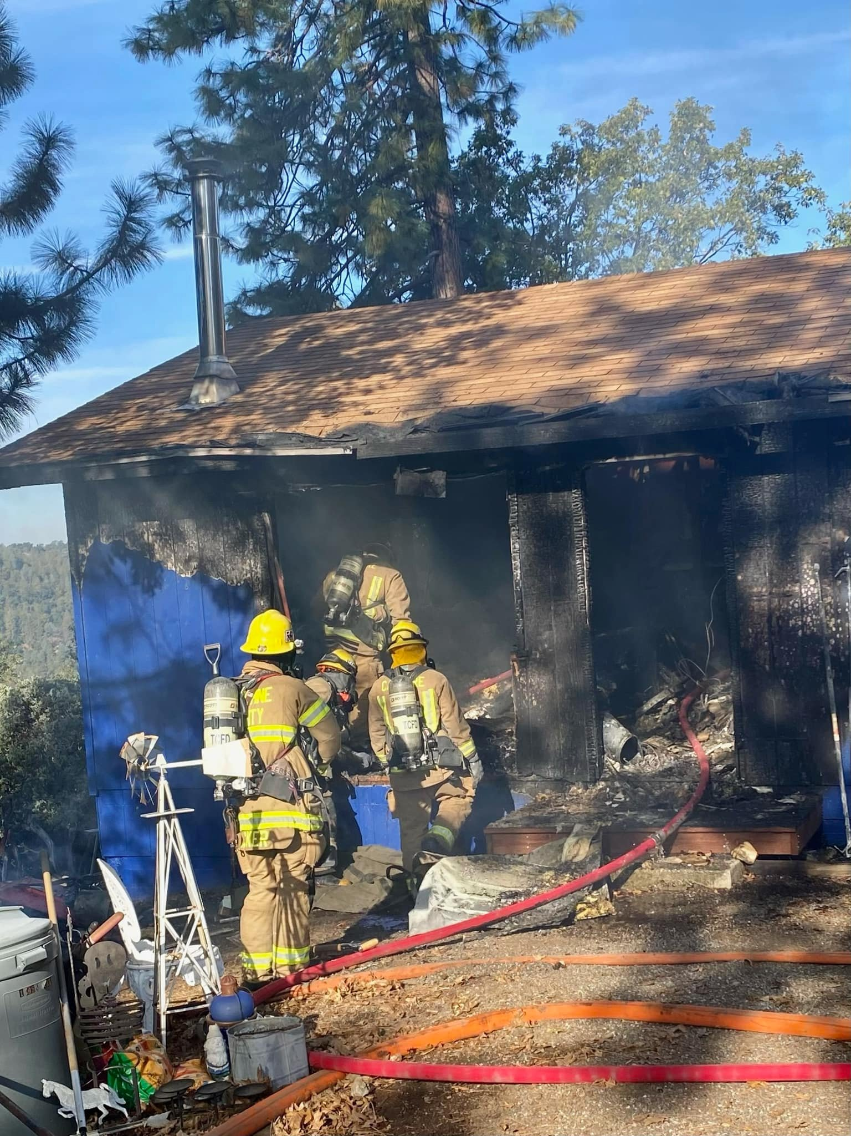

11/2/2023
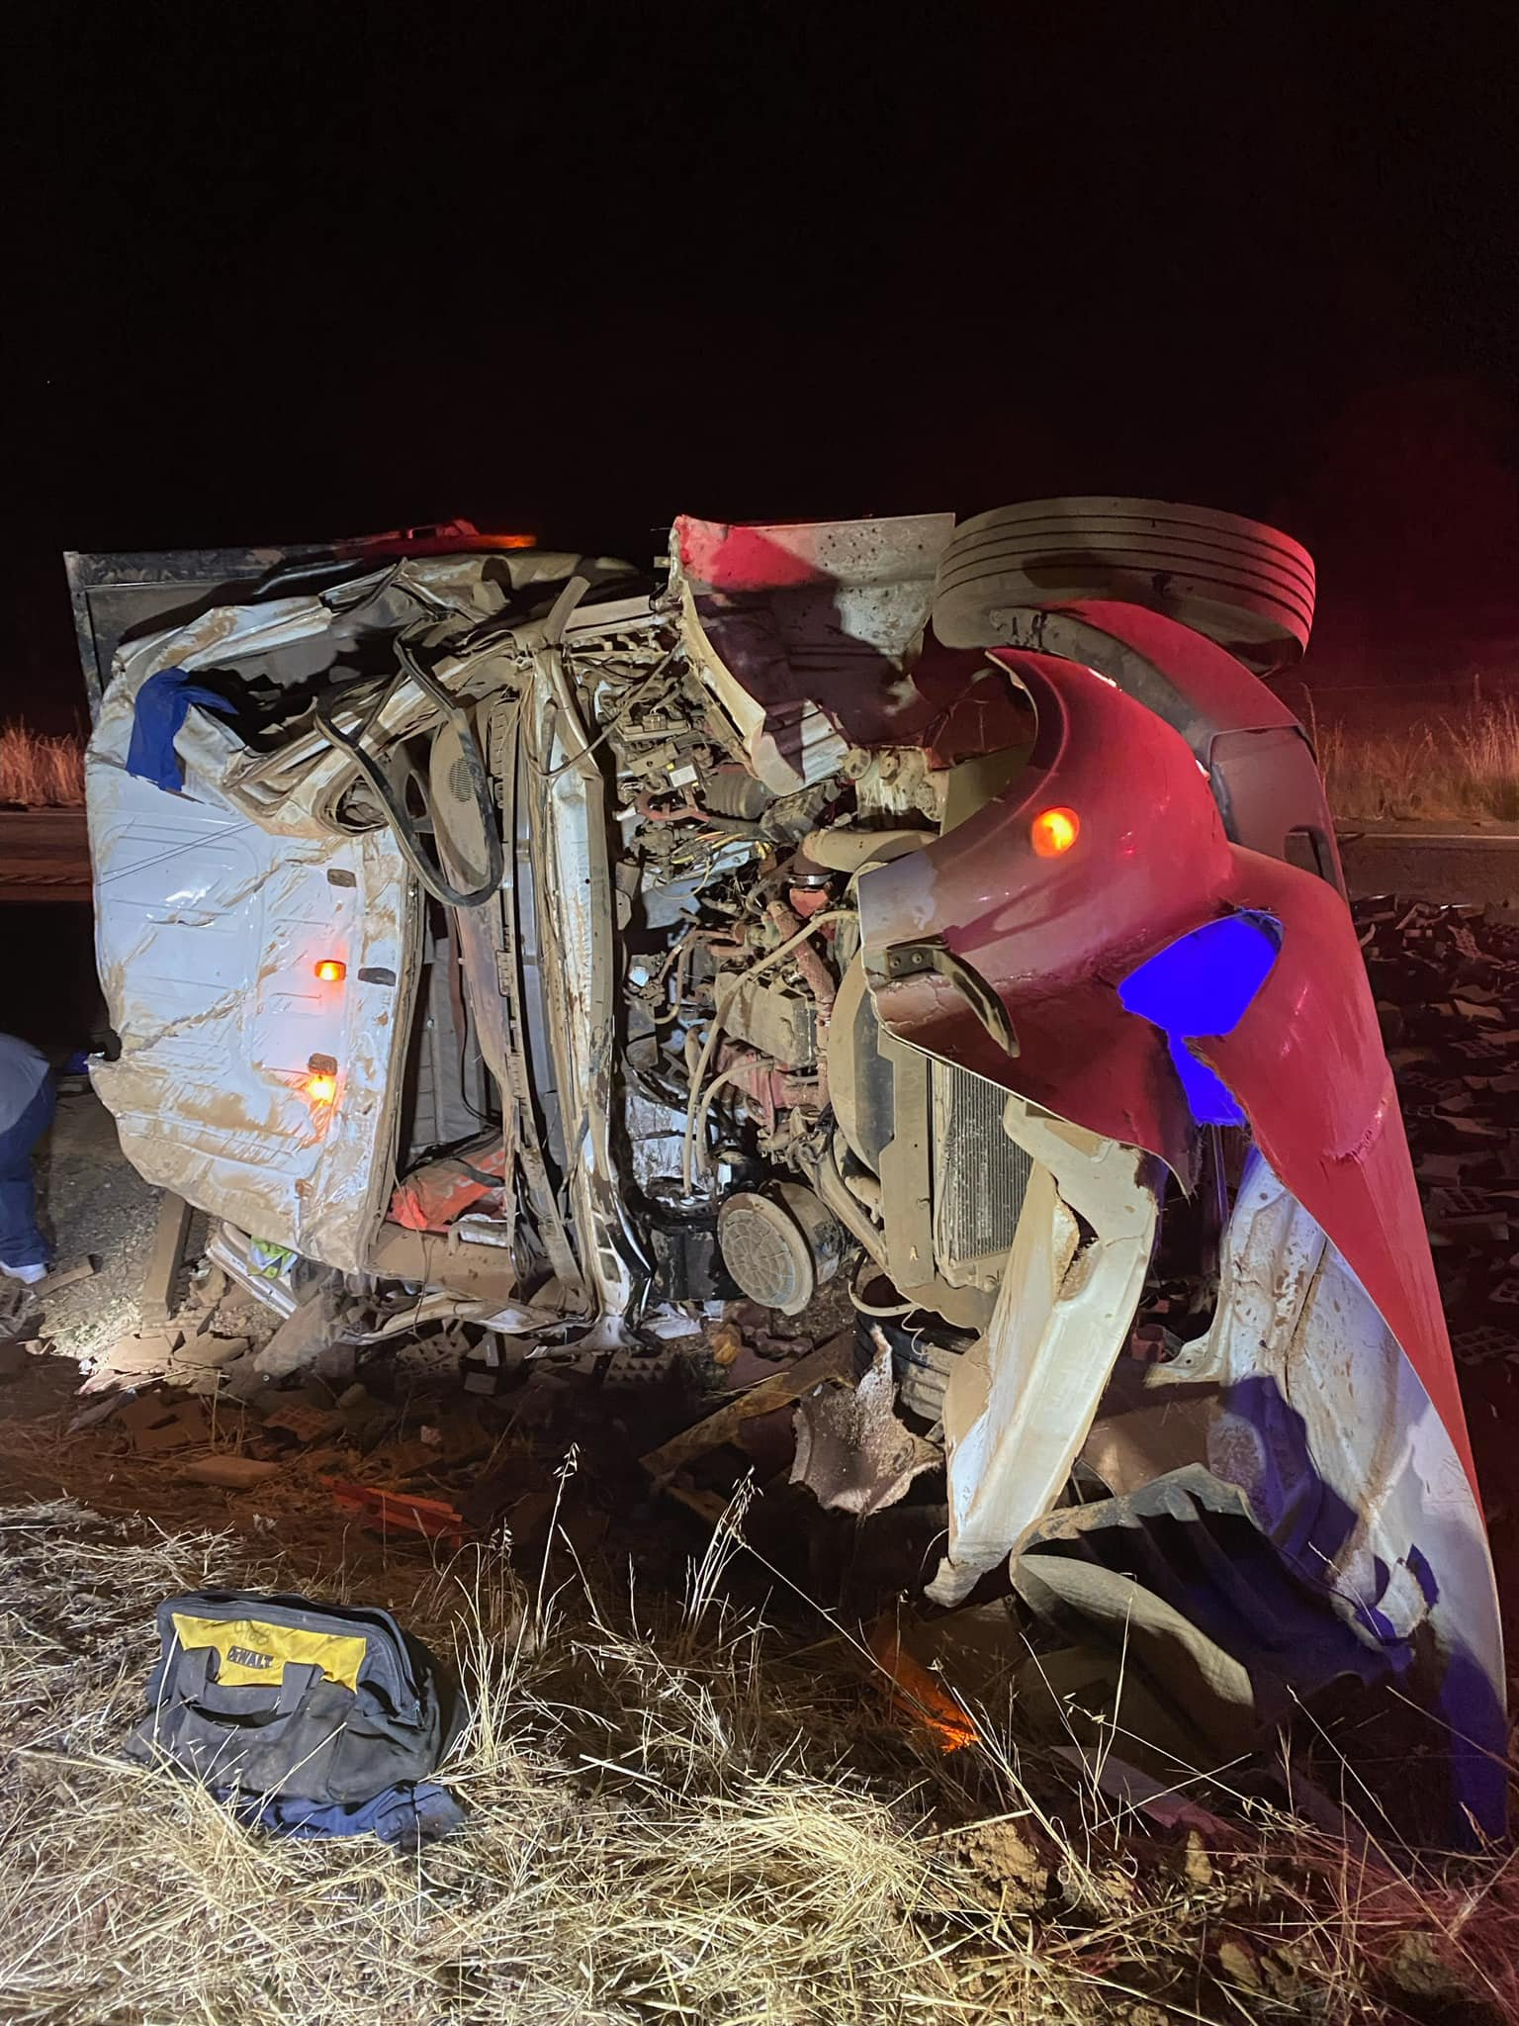
On the evening of November 2nd, resources from the Tuolumne County Fire Department, CAL FIRE Tuolumne-Calaveras Unit, Tuolumne County Ambulance, and CHP Sonora were dispatched on a rescue response to a reported vehicle accident with entrapment in the area of J59 near Seven Legends. Crews arrived to find one patient trapped in an overturned commercial vehicle that had been transporting a large load of rubber bricks. Crews utilized hydraulic extrication tools to rapidly free the patient who was transported by ground ambulance to a local hospital.

11/14/2023
At approximately 12:40 PM resources from the Tuolumne County Fire Department, CAL FIRE Tuolumne-Calaveras Unit, and the Groveland Community Services District responded to a reported escaped debris burn in the area of Highway 120 and Grizzly Road near the community of Moccasin in southern Tuolumne County. Quick action by firefighters held the fire to a half acre and a citation was issued for allowing the fire to escape.
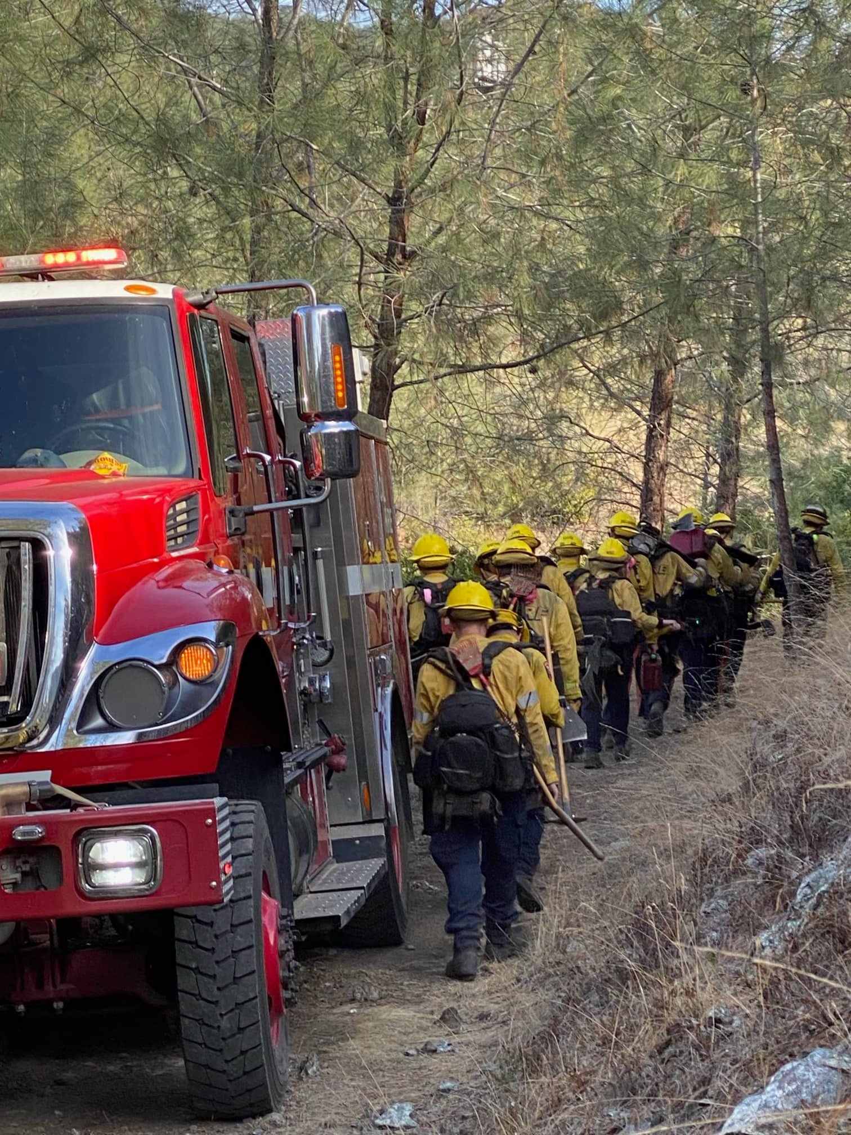
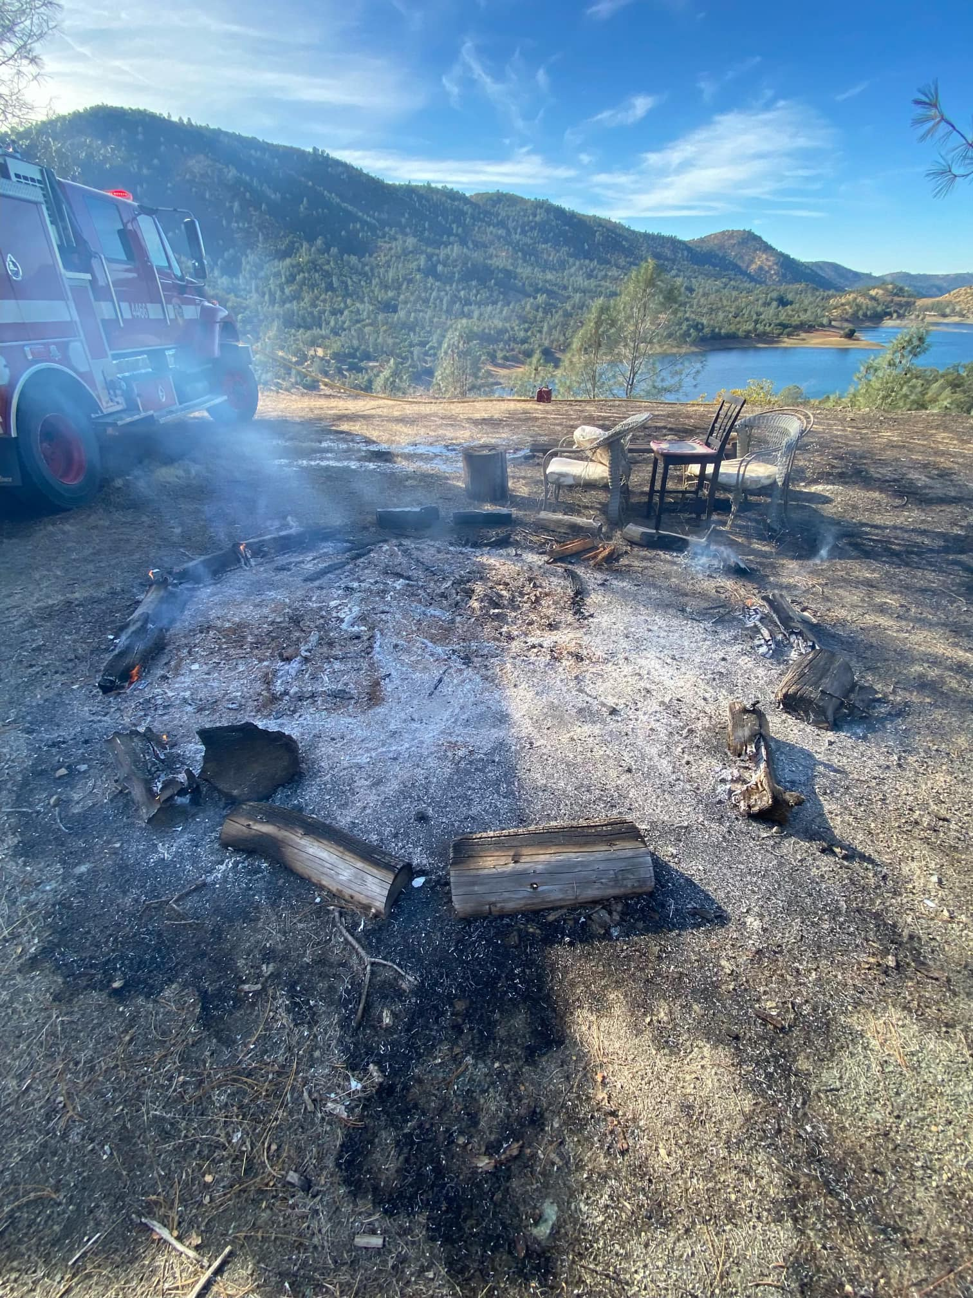

11/20/23
In the morning hours resources from Tuolumne County Fire Department, CAL FIRE Tuolumne-Calaveras Unit, and Twain Harte Fire Department responded to a reported residential structure fire near the community of Crystal Falls. First arriving resources found a working fire in a bedroom of the structure and a single occupant with injuries. Firefighters administered first aid while also initiating an aggressive interior attack on the fire. Strong working relationships between the multiple agencies allowed the firefighters to contain the fire to a single room of the structure preventing it from spreading to the rest of the structure. The occupant of the home was flown by air ambulance to a hospital out of the area for treatment. The cause of the fire remains under investigation.
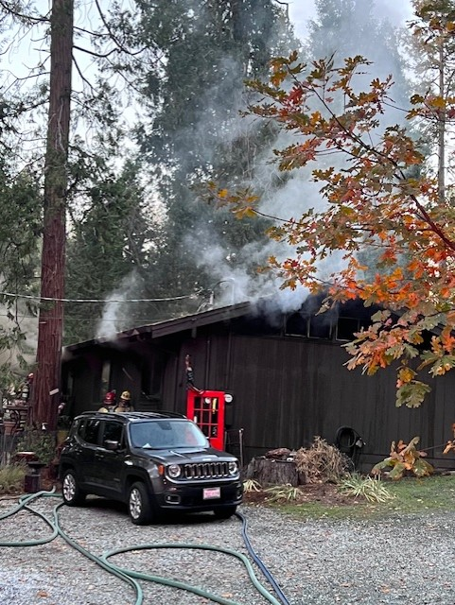

11/21/23
At approximately 1:15 PM Tuolumne County Fire Department engines 511 and 561 responded with Tuolumne County Ambulance and CHP Sonora to a reported vehicle accident in the area of Mono Way and Cordelia Avenue in East Sonora. Resources arrived at scene to find a single vehicle that had rolled over located on the shoulder of Mono Way. There was one occupant of the vehicle who had self-extricated prior to resources arriving at scene and had no injuries.
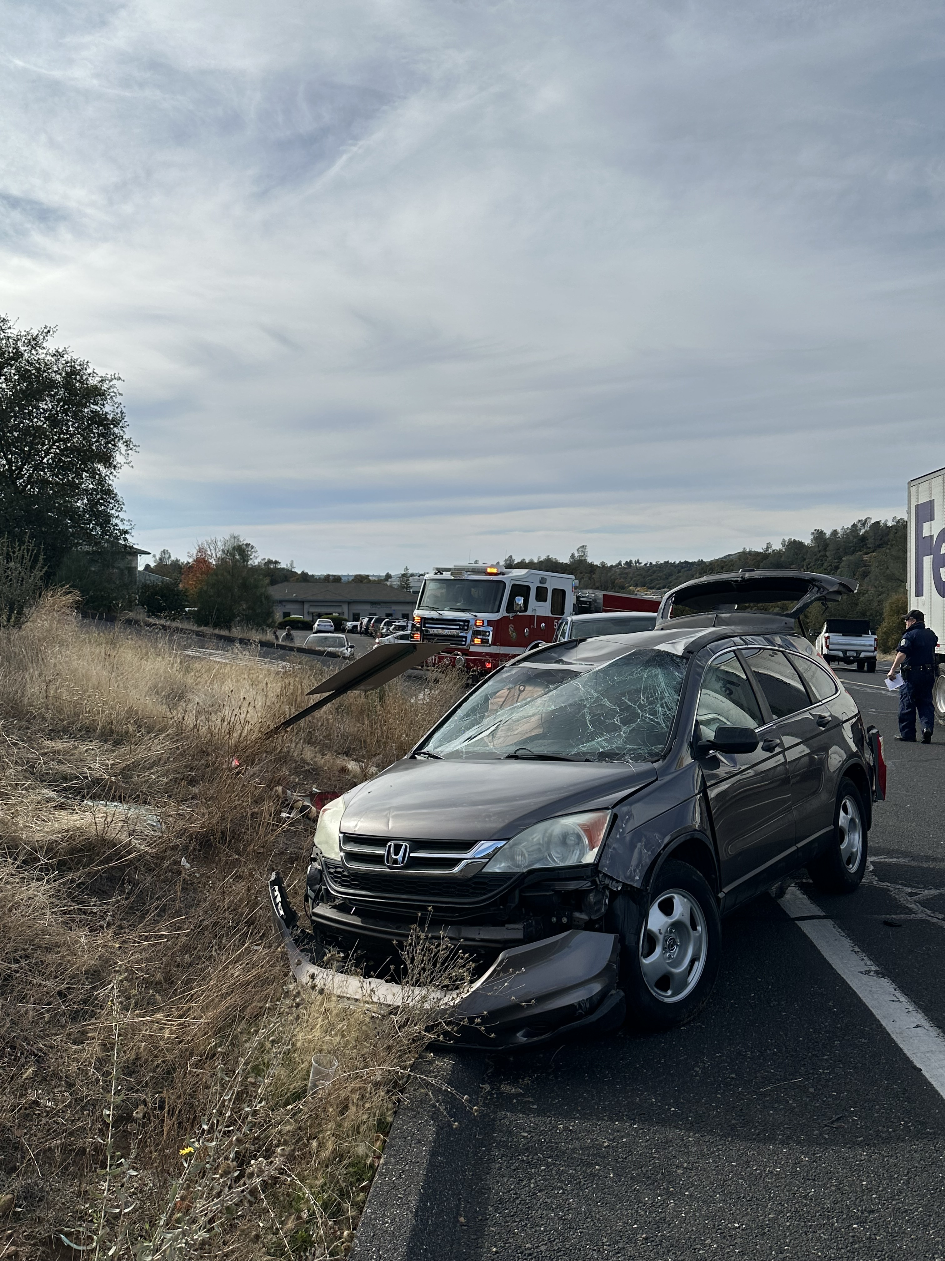

11/28/2023
At approximately 6:30 PM resources from the Tuolumne County Fire Department and CAL FIRE Tuolumne-Calaveras Unit were dispatched to a reported vehicle fire near Highway 108 and Via Este Road. Crews arrived to find a single vehicle on the shoulder of the roadway fully involved. Quick work by crews extinguished to fire and contained it to the vehicle with no extension to the wildland. All occupants of the vehicle were able to safely exit the vehicle with no injuries.
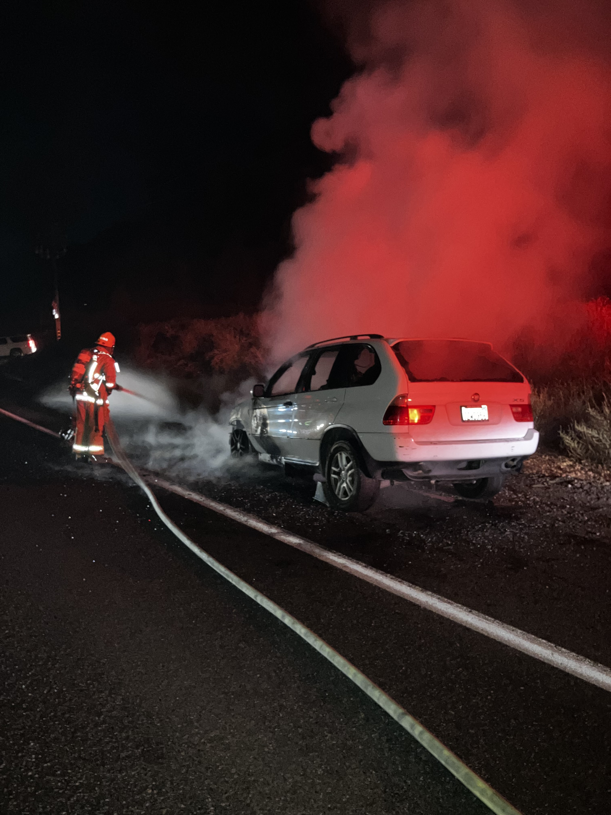
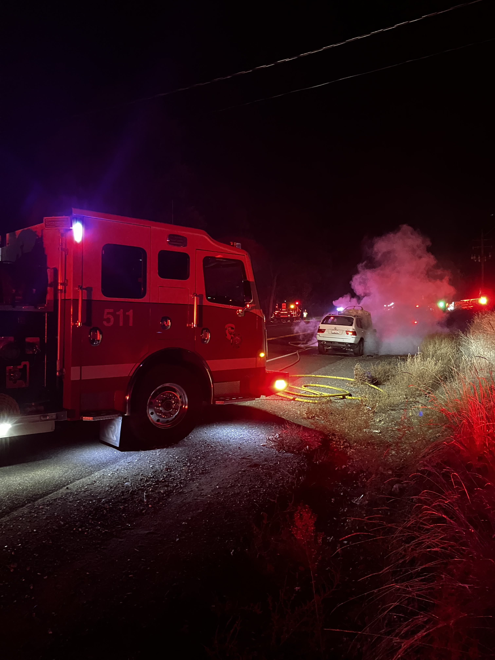

Community Events
11/18/2023
On Saturday, November 18th crews from the Tuolumne County Fire Department and CAL FIRE Tuolumne-Calaveras Unit joined together with the Muscular Dystrophy Association (MDA) to participate in the annual Fill the Boot Event. Firefighters were out on Mono Way and Tuolumne Road near the Junction Shopping Center to help raise money and fight muscular dystrophy. More than 60 personnel were out encouraging the public to help and for the third consecutive year the Tuolumne-Calaveras Unit record was broken by raising over $18,000.00!
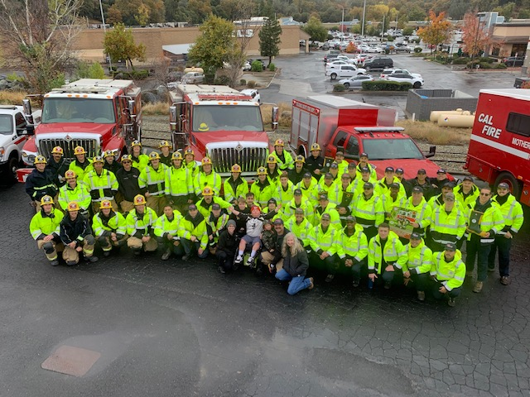

11/24/2023
On Friday, November 24th the Tuolumne County Fire Department was honored to participate in the 40th Annual Christmas Parade. This event is a kick-off to the Holiday season and we were proud to showcase engines, water tenders, and other pieces of equipment that helps us serve our Community!
